CSI

1, What are main features of the von Neumann model? (same with CPU)

Von Neumann model is divided into 4 subsystems :

♣ Memory is the storage area. This is where programs and data are stored during processing

♣ Arithmetic logic unit (ALU) is where calculation and logical operations take place

♣ Control unit controls the operations of the memory, ALU, and the input/output

♣ The input subsystem accepts input data and the program from outside the computer, while the output subsystem sends the result of processing to the outside world.

2, What is the difference (hardware, software) between computer generations?

**1.First Generation Computers** : Vacuum Tubes, useful to process the data in memory.  
**2.Second-generation computers (roughly 1959–1965)** used transistors, Two high-level programming languages, FORTRAN and COBOL.  
**3.Third Generation Computers (1965-1975)** integrated circuit (transistors, wiring, and other components on a single chip) + Minicomputers appeared on the market   
**4.The fourth generation (approximately 1975– 1985)** saw the appearance of microcomputers + The first desktop calculator + Advances in the electronics industry allowed whole computer subsystems to fit on a single circuit board.  
**5.Fifth Generation (Present and Beyond)** computing devices, based on artificial intelligence + The ability to translate a foreign language + The goal of fifth generation computing is to develop devices that respond to natural language input and are capable of learning and self-organization

3, What is the role of CPU in the computer?

The central processing unit (CPU) performs operations on data or **retrieves and executes instructions**

4, How does the CPU perform a instruction?

1 fetch – 2 decode – 3 execute – 4 store – repeat 1

5, What distinguishes between RAM and ROM?

**RAM is volatile memory that temporarily stores the files you are working on.**  
**ROM is non-volatile memory that permanently stores instructions for your compute**

**Volatile (bay hơi)**

6, Why can the cache memory increase a the computer's performance?

**because it is located closer to the CPU**, it can get and start processing the instructions and data much more quickly

1, How to control input/output subsystems in a computer?

2, What is the difference between RISC and CISC in the design of computer architecture?

3, What is the role of number system in a computer?

4, How to convert a number in the number system (2,8,16,10) to other number systems?

QN1: Distinguish between positional and nonpositional number systems

1. **In non-positional number system, each symbol represents the same value regardless of its position**. 2. In non-positional number system, each symbol represents a number with its own place value.

QN2: What is the relationship between a base and the number of symbols in a positional number system?

A digital system can understand positional number system only where there are a few symbols called digits and these symbols represent different values depending on the position they occupy in the number.

The base of the number system (where base is defined as the total number of digits available in the number system).QN3: Explain the each number system. Why is it called?

QN4: What rules are there used for nonposition number system?

A non-positional number system **uses a limited number of symbols in which each symbol has a value**

QN5: Why is it easy to convert from binary to hexadecimal and vice versa?

Converting between hex and binary is easy, because **each digit of a hexadecimal number "maps" to four bits (a bit being an individual binary digit) of a binary value**. So a byte -- eight binary digits -- can always be represented by two hexadecimal digits.

Vì 2^4 = 16 nên mỗi 4 bit đều có thể được biểu diễn bằng 1 ký tự Hex, 1 byte được biểu diễn bằng 2 ký tự Hex

QN6: How to convert between postion number system? Explain using flow-chart and algorithm

Here the algorithm:

step 1: read the number

step 2: declare stack

step 3: repeat step 4 and 5 till value=0

step 4: push back value%10

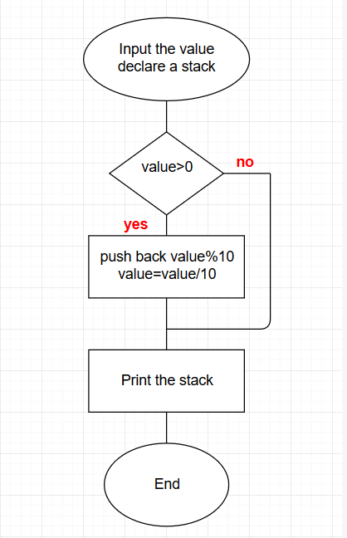step 5: value = value /10

step 6: print the stack